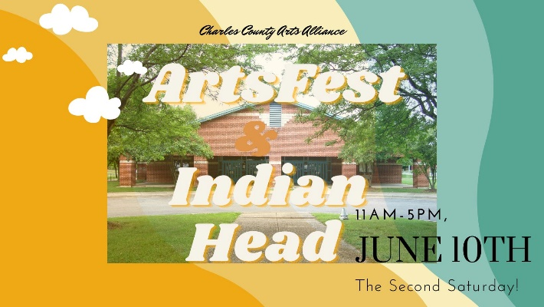
Please complete this entire section:
Organization Name:
Point of Contact:
Street Address:
Mailing Address (if different):
City: | State: | Zip Code:
Primary Phone (cell/home/work):
Alternate Phone (cell/home/work):
Email Address:
Website:
Special Requirements (handicap access, etc.):
Describe your booth display:

Site preference (circle one): Inside Pavilion____ Outside Pavilion____
No Preference____
Number of booth spaces required: ____________ x registration fee = $______________
Number of 8ft Table space required: ________x registration fee = $________
PLEASE NOTE:
- Fees are based on one 10’ x 10’ tent space outside or one 8ft long table indoors.
- Electricity is not available.
- You are responsible for providing all tables, chairs, popup tents, canopies, display hardware, etc.
- Exhibitors are encouraged to create, demonstrate, and actively engage the public throughout the day. Hands-on activities are also encouraged for children and adults.
- In case of severe weather, call the CCAA office at 301-392-5900 for a recorded message. Cancelation will be determined by 6:00 PM on Friday, June 10th. Rain day TBD.
- Vendors and Exhibitors not in their booth spaces by 11:00 AM will not be allowed to enter. All participants agree to remain in their space until they are directed by a CCAA representative to close down, at 4:30 PM or 5:00 PM.

By signing this form, you agree to all terms. Please mail this completed form and your payment to Charles County Arts Alliance, PO Box 697, White Plains MD 20695.

___________________________________ _______________________________________
Signature Date

